IBRA CISSE

jason Jensen

MEdicine recommandation fINAL REPORT

**Table of Content**

1. Abstract………………………………………………………………………3
2. Introduction…………………………………………………………………4
3. Database Description……………………….…………………………….5
4. Database Functionalities….……………….…………………………….5
5. Relationship…………………………………………………………………7
6. Use Cases……………………………………………………………………8
7. E/R Diagram………………………………………………………………11
8. Relational Model………………………………………………………….12
9. Database Prototype………………………………………………………13
10. Test Plan……………………………………………………………………14
11. Final report of the test plan……………………………………………15
12. Time Management Plan………………………………………………...16

**Abstract**

When sick, a trip to the drug store is an unpleasant endeavor. Even knowing your illness, choosing the best medication to alleviate your symptoms can be difficult due to the large number of options available. This project would make this choice, and therefore the trip, much simpler. By inputting a list of symptoms, the database will cross reference and recommend the best medication for your symptoms. Medication is ranked according to effectiveness based on an ever growing list of surveys. These symptoms would include: headaches, toothaches, stomachaches, allergies, etc.

**Introduction**

This project is meant to help regular people choose the best over the counter medication for minor illnesses. The concept is to develop a system where users can input the symptoms that they are experiencing and based on research and feedback from customers and medical documentation, we provide a recommendation of the best over the counter pills to take to alleviate the symptoms. The application will use several tables and databases which will have several indexed tables. The databases will be tied to each other with an index id to quicken queries. Once queried the application will search the databases that contain a medicines description and ranking, based on reviews from other users and scientific documentations, queries will then return the top sorted medicines for the specified symptoms along with their description. The results will be presented through a custom made user interface. Users will be able to select from drop down menus to view medicine descriptions and ranking. Users will also have the choice to log in and write reviews which will influence the ranking of medication.

**Database Description**

This database will allow most people to select the best medication to alleviate symptoms whilst sick. Our intent is to provide a recommendation for the best medication for minor illnesses that do not warrant a trip to a doctor or to simply have on hand as first aid. Within our ER diagram, we have included preliminary Primary keys and all references this project will have. This might change as we progress further into development and create a more consistent recommendation system based on ratings and reviews. Different users will have different views based on their level of access. For example, an administrator will be able to create, add, or delete rows based on the circumstances such as adding new medicine, archiving medicine that has poor reviews, or updating relevance of reviews and ratings. The typical user will be able to view medicines, rate medicine, and write a review for future users.

**User Requirement**

The requirement for the product is to have either SQL database or use MYSQL work bench in order to view the information. The entire database can be created and replicated based on commands from files that we have. Within the file, we have commands for the database such as:

* + - 1. Drop database;
      2. Create database medicine;
      3. Create table …..
      4. Update ….

Those commands will allow you to replicate the database via SQL or MYSQL. From there, a user is require to have username and password in order to log in.

Their privilege is limited besides updating ranks, writing reviews and adding medicine. They cannot delete or create new tables. However, administrator has all the rights to go through the entire database and make all changes to the existing database. They can delete, add table, delete users, create new users and forth.

**System Requirement**

The requirement for this project is not much. It is multi-platform supported due to the entire database and primitive information is already filled and ready to be imported as a text file. In order to do this, you need either phpadmin for the database and import it as a text file and run the commands to create the database, or you can run the import command on MYSQL and it will take care of everything for you.

**Database Functionalities**

The following database will focus on 3 different type of aspect of view as of Administrator, user, and client. Each one of the following has specific roles and regulation on what they can do and access based on their rights set up by the database manager:

1. **Users**

Users are typical users who do not any rights but write reviews and increase the rate of a medicine. These are regular people that visit and can get their daily services.

1. **Client**

The client is a user register within the database. They have to be authenticated from the database and given the respect view. Their roles and right include being able to request data from the database such as most popular medicine for a sickness, average of all the ranked medication, highest or lowest rank medicine for a certain type of disease. Clients can also change the rank of medicines and delete reviews.

1. **Administrator role and functionalities**

The Administrator is the database manager and also controls everything within the database. Administrator has the right and roles to create new tables, update tables, and change table outcomes. The administrator can also delete tables or delete the existing database as well as initiate a backup of the database. Administrator can also change the rank of medicines and delete reviews.

1. **Database Functionalities**
2. Table for clients which will include Index ID, username, password, first name, last name, age, and sex.
3. Another table will hold medicine which will be linked to the clients’ table by IDs as primary keys, and the rest will have foreign keys. As for medicines, they will have several rows that holds the brand and generic names as well as the description and usage.
4. A third table will hold all of the symptoms that someone might have. These will have a description field where they will be linked to other tables such as medicine and which users have listed them before.
5. A rating and review table which will be linked to client, medicine, and sickness by indexed ids. The remaining fields will have foreign keys for faster access to information.
6. Administrators will be able to update all fields, create new fields, update rows, and change ratings.
7. Administrator will be able to delete rows based on relevant information that have been given or recorded on the database
8. Users will be able to register and log in to write reviews, rate medicine, and give suggestion.
9. Another table will be called Chemical Component, this table holds the chemical makeup of the medicine along with its known side effects. This table will be linked to both medicine and rating as well.

**Relationships between Tables**

* The client and medicine tables will be linked based on IDs which will be the primary key. The rest will be foreign keys.
* The medicine table will be linked with the symptom table, each medicine will become a member of a symptom, which will hold a description of that symptom and the medicine most recommended to alleviate it.
* Ratings and reviews will be linked to the symptom and the medicine tables, it will be based on how many reviews have been received. Each review will be rated from 1 to 10.
* Updating will go to the targeted field based on customer ID, then the symptom table and the medicine will be given a review and rating. The average rating, along with number of reviews, will be display towards top bar of the pages
  + Two different type of client: regular user and administrator
  + Administrator can make changes towards core database
  + User can only update information and rating systems through reviews.
* The symptoms Table will contains all the symptoms for that specific illness. The symptoms will be linked to the client and Administrator table based on primary key with the same IDs field, names, and last names.
* Review will also be linked by primary keys to the client and Administrator table, from there, they will be linked to medicine, and symptoms.
* Medicine Sales values table will have the foreign keys to medicine table, and review.

**Use Cases and Scenarios for the database**

The following has several possible use cases for the databases and its entities.

**Case 1: User ask for average rank on medicine**

Input: search for average price

Output: database is query and returns the average price from specific table such as Sales Price, and also name of the medicine.

**Case 2: user asked for highest rated medicine for a specific sickness**

Input: user asked for the highest rated for headache

Output: query the select statement to show the highest rated medicine for headache, bring back which cities it is available and also their rating.

**Case 3: User writes a review for a medicine**

Input: writes a review on a textbox and submit it to the database.

Output: database executes the update statement, select a specific table and update the review and ranking based on the input. Also user is never recoded because it is a regular user.

**Case 4: user try to create a table**

Input: create a table for new attributes

Output: users cannot create new attributes or change attributes due to their restrictive rights.

**Case 5: User sings up to be a client**

Input: sign up process by providing username, first name, last name, password, repeated password, sex, age.

Output: insert statement is done and user can be query and added to a table as a client. Given the client rights, user can now alter tables but not create them, they can update rating and so forth….

**Case 6: Client signs in**

Input: input username and password

Output: select statement is queried and retrieved. Compare if the information are matching. If matching, then client can see their view. If the information is not matching, client will be redirected to entering username and password.

**Case 7: Client signs out**

Input: click the sign-out button

Output: closes the view and bring back the regular view which can only search and view basic information.

**Case 8: client updates review**

Input: writes a review in the provided textbox and then

Output: insert the review into the review table and change the rank if effected.

**Case 9: client updates rating for medicine**

Input: input the number of starts in the textbox

Output: goes to the review table and update the ranking either by higher or lower. This effects its status based on the number of starts it has

**Case 10: client update the review board for a medicine**

Input: input a new price for a medicine.

Output: database returns an error because client do not have the right to change this type of specification

**Case 11: Administrator log on**

Input: input username and password

Output: Administrator will be queried and see if his information matches. If matches, view will be changed and Admin can change anything due to all rights given.

**Case 12: Administrator logs out**

Input: clicks sign out

Output: Administrator view will be close, return back to sign in mode.

**Case 13: Administrator deletes a table**

Input: inputs delete a specific table

Output: database query the statement as "DELETE FROM medical Database WHERE table = “specific table”". Then the table will be deleted and return a successful answer.

**Case 14: Administrator creates a new table**

Input: create a new table by giving the entities of the table such as the type of information it can hold.

Output:

**Case 15: Administrator adds to the a table**

Input: uses the insert data and specified which table to insert it to

Output: inserts new record on the table and return successful

**Case 16: Administrator deletes a record from the database**

Input: uses the delete method by providing the specific table, which data to delete.

Output: data is deleted based on specification and also return successful.

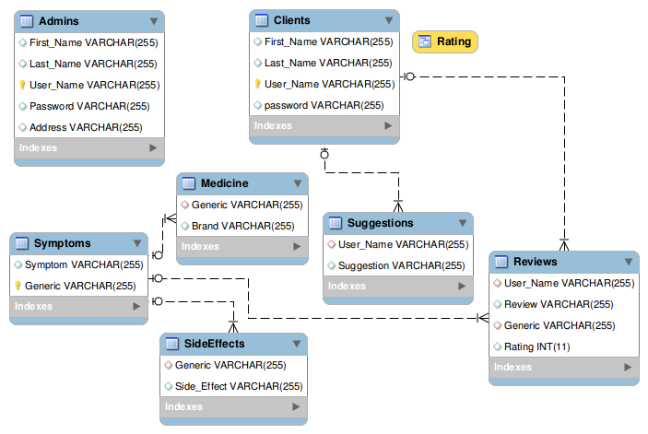

**SQL Dump from the database**

-- MySQL dump 10.13 Distrib 5.5.47, for debian-linux-gnu (x86_64)

--

-- Host: localhost Database: DB

-- ------------------------------------------------------

-- Server version 5.5.47-0ubuntu0.14.04.1

/*!40101 SET @OLD_CHARACTER_SET_CLIENT=@@CHARACTER_SET_CLIENT */;

/*!40101 SET @OLD_CHARACTER_SET_RESULTS=@@CHARACTER_SET_RESULTS */;

/*!40101 SET @OLD_COLLATION_CONNECTION=@@COLLATION_CONNECTION */;

/*!40101 SET NAMES utf8 */;

/*!40103 SET @OLD_TIME_ZONE=@@TIME_ZONE */;

/*!40103 SET TIME_ZONE='+00:00' */;

/*!40014 SET @OLD_UNIQUE_CHECKS=@@UNIQUE_CHECKS, UNIQUE_CHECKS=0 */;

/*!40014 SET @OLD_FOREIGN_KEY_CHECKS=@@FOREIGN_KEY_CHECKS, FOREIGN_KEY_CHECKS=0 */;

/*!40101 SET @OLD_SQL_MODE=@@SQL_MODE, SQL_MODE='NO_AUTO_VALUE_ON_ZERO' */;

/*!40111 SET @OLD_SQL_NOTES=@@SQL_NOTES, SQL_NOTES=0 */;

--

-- Table structure for table `Admins`

--

DROP TABLE IF EXISTS `Admins`;

/*!40101 SET @saved_cs_client = @@character_set_client */;

/*!40101 SET character_set_client = utf8 */;

CREATE TABLE `Admins` (

`First_Name` varchar(255) DEFAULT NULL,

`Last_Name` varchar(255) DEFAULT NULL,

`User_Name` varchar(255) NOT NULL,

`Password` varchar(255) DEFAULT NULL,

`Address` varchar(255) DEFAULT NULL,

PRIMARY KEY (`User_Name`)

) ENGINE=InnoDB DEFAULT CHARSET=latin1;

/*!40101 SET character_set_client = @saved_cs_client */;

--

-- Dumping data for table `Admins`

--

LOCK TABLES `Admins` WRITE;

/*!40000 ALTER TABLE `Admins` DISABLE KEYS */;

INSERT INTO `Admins` VALUES ('Ibra','Cisse','icisse','BigBlack','87706 Washington AV'),('Jason','Jensen','JJensen','Test','78548 Wahsington AV');

/*!40000 ALTER TABLE `Admins` ENABLE KEYS */;

UNLOCK TABLES;

--

-- Table structure for table `Clients`

--

DROP TABLE IF EXISTS `Clients`;

/*!40101 SET @saved_cs_client = @@character_set_client */;

/*!40101 SET character_set_client = utf8 */;

CREATE TABLE `Clients` (

`First_Name` varchar(255) DEFAULT NULL,

`Last_Name` varchar(255) DEFAULT NULL,

`User_Name` varchar(255) NOT NULL,

`password` varchar(255) DEFAULT NULL,

PRIMARY KEY (`User_Name`)

) ENGINE=InnoDB DEFAULT CHARSET=latin1;

/*!40101 SET character_set_client = @saved_cs_client */;

--

-- Dumping data for table `Clients`

--

LOCK TABLES `Clients` WRITE;

/*!40000 ALTER TABLE `Clients` DISABLE KEYS */;

INSERT INTO `Clients` VALUES ('Brown','Harris','bHarris','dF49JR5QHI'),('Baker','Parker','bParker','4H0ygospiC'),('Campbell','Miller','cMiller','rLTs1wMDFe'),('Collins','Rodriguez','cRodriguez','Uz7Q3c6n0s'),('Clark','Wright','cWright','cedP8TMDeq'),('Davis','Martin','dMartin','IJ8RgrLRUO'),('Evans','Moorn','eMoorn','oY3jSdhcew'),('Hall','Adams','hAdams','MOfXDmg9mQ'),('King','Carter','kCarter','7ukTrGVrRH'),('Lewis','Hill','lHill','lKhuCvaBjq'),('Lopez','Perez','lPerez','NSjwCvVtAC'),('Martinez','Hernandez','mHernandez','O3YcnPvW9j'),('Mitchell','Johnson','mJohnson','DdFebCbA2w'),('Nelson','Edwards','nEdwards','AXDUZqKgcR'),('Roberts','Jones','rJones','LT38xN2InH'),('Smith','Anderson','sAnderson','qT1eNTBGYa'),('White','Lee','sLee','o3HO7BjFcW'),('Scott','Turner','sTurner','kibnV0OzR4'),('Thompson','Allen','tAllen','uV2B04I8DH'),('Thomas','Phillips','tPhillilps','Iu3hAaZDJH'),('Taylor','Robinson','tRobinson','6G0oJdYaBN'),('Wilson','Garcia','wGarcia','eI1oKxjtWM'),('Walker','Green','wGreen','opAeVRUxoN'),('Williams','Jackson','wJackson','xJpFsadqBL'),('Young','Gonzalez','yGonzalez','G8O0OmbZsT');

/*!40000 ALTER TABLE `Clients` ENABLE KEYS */;

UNLOCK TABLES;

--

-- Table structure for table `Medicine`

--

DROP TABLE IF EXISTS `Medicine`;

/*!40101 SET @saved_cs_client = @@character_set_client */;

/*!40101 SET character_set_client = utf8 */;

CREATE TABLE `Medicine` (

`Generic` varchar(255) DEFAULT NULL,

`Brand` varchar(255) DEFAULT NULL

) ENGINE=InnoDB DEFAULT CHARSET=latin1;

/*!40101 SET character_set_client = @saved_cs_client */;

--

-- Dumping data for table `Medicine`

--

LOCK TABLES `Medicine` WRITE;

/*!40000 ALTER TABLE `Medicine` DISABLE KEYS */;

INSERT INTO `Medicine` VALUES ('Pseudoephedrine','Chlor Trimeton Nasal Decongestant'),('Pseudoephedrine','Contac Cold'),('Pseudoephedrine','Drixoral Decongestant Non-Drowsy'),('Pseudoephedrine','Elixsure Decongestant'),('Pseudoephedrine','Entex'),('Pseudoephedrine','Genaphed'),('Pseudoephedrine','Kid Kare Drops'),('Pseudoephedrine','Nasofed'),('Pseudoephedrine','Seudotabs'),('Pseudoephedrine','Silfedrine'),('Pseudoephedrine','Sudafed'),('Pseudoephedrine','Sudafed 12-Hour'),('Pseudoephedrine','Sudafed 24-Hour'),('Pseudoephedrine','Sudafed Children\'s Nasal Decongestant'),('Pseudoephedrine','Sudodrin'),('Pseudoephedrine','SudoGest'),('Pseudoephedrine','SudoGest 12 Hour'),('Pseudoephedrine','Suphedrin'),('Pseudoephedrine','Triaminic Softchews Allergy Congestion'),('Pseudoephedrine','Unifed'),('Esomeprazole','Esomeprazole Strontium'),('Esomeprazole','NexIUM'),('Diazepam','VALIUM'),('Acetaminophen','Actamin'),('Acetaminophen','Apra'),('Acetaminophen','Mapap'),('Acetaminophen','Q-Pap'),('Acetaminophen','Tactinal'),('Acetaminophen','Tempra'),('Acetaminophen','Tycolene'),('Acetaminophen','Tylenol'),('Acetaminophen','Vitapap'),('Minocycline','Dynacin'),('Minocycline','Minocin'),('Minocycline','Minocin PAC'),('Minocycline','Solodyn'),('Minocycline','Vectrin'),('Minocycline','Myrac'),('Haloperidol','Haldol'),('Cephalexin','Keflex'),('Cephalexin','Panixine'),('Cephalexin','Biocef'),('Cephalexin','Zartan'),('Aripiprazole','Abilify'),('Aripiprazole','Abilify Discmelt'),('Aripiprazole','Abilify Maintena'),('Aripiprazole','Aristada'),('Adalimumab','Humira'),('Adalimumab','Humira Pen'),('Adalimumab','Humira Pen Crohns Disease/Ulcerative Colitis Starter Package'),('Adalimumab','Humira Pen Psoriasis Starter Package'),('Adalimumab','Humira Pediatric'),('Adalimumab','Humira Pediatric Crohn\'s Disease Starter Pack'),('Rosuvastatin','Crestor'),('Fluticasone','Advair Diskus'),('Fluticasone','Advair HFA'),('Etanercept','Enbrel'),('Etanercept','Enbrel Prefilled Syringe'),('Etanercept','Enbrel SureClick'),('Infliximab','Remicade'),('Infliximab','Inflectra'),('Duloxetine','Cymbalta'),('Duloxetine','Irenka'),('Insulin Glargine','Basaglar KwikPen'),('Insulin Glargine','Lantus'),('Insulin Glargine','Lantus Solostar Pen'),('Insulin Glargine','Toujeo SoloStar'),('Insulin Glargine','Lantus OptiClik Cartridge'),('Tiotropium','Spiriva'),('Tiotropium','Spiriva Respimat 14 Dose'),('Tiotropium','Spiriva Respimat 30 Dose'),('Tiotropium','Spiriva Respimat 28'),('Tiotropium','Spiriva Respimat'),('Sitagliptin','Januvia');

/*!40000 ALTER TABLE `Medicine` ENABLE KEYS */;

UNLOCK TABLES;

--

-- Temporary table structure for view `Rating`

--

DROP TABLE IF EXISTS `Rating`;

/*!50001 DROP VIEW IF EXISTS `Rating`*/;

SET @saved_cs_client = @@character_set_client;

SET character_set_client = utf8;

/*!50001 CREATE TABLE `Rating` (

`Generic` tinyint NOT NULL,

`Rating` tinyint NOT NULL

) ENGINE=MyISAM */;

SET character_set_client = @saved_cs_client;

--

-- Table structure for table `Reviews`

--

DROP TABLE IF EXISTS `Reviews`;

/*!40101 SET @saved_cs_client = @@character_set_client */;

/*!40101 SET character_set_client = utf8 */;

CREATE TABLE `Reviews` (

`User_Name` varchar(255) DEFAULT NULL,

`Review` varchar(255) DEFAULT NULL,

`Generic` varchar(255) DEFAULT NULL,

`Rating` int(11) DEFAULT NULL,

KEY `User_Name` (`User_Name`),

CONSTRAINT `Reviews_ibfk_1` FOREIGN KEY (`User_Name`) REFERENCES `Clients` (`User_Name`)

) ENGINE=InnoDB DEFAULT CHARSET=latin1;

/*!40101 SET character_set_client = @saved_cs_client */;

--

-- Dumping data for table `Reviews`

--

LOCK TABLES `Reviews` WRITE;

/*!40000 ALTER TABLE `Reviews` DISABLE KEYS */;

INSERT INTO `Reviews` VALUES ('sAnderson','This medicine is super awesome for cold.','Pseudoephedrine',10),('cWright','I took this medicine when I had headache, and it helped me out good.','Acetaminophen',9),('mJohnson','This medicine is not for everyone who has issues with gas, but it worked for me.','Esomeprazole',8),('tPhillilps','Had asthma, hate inhalers, but this medicine works really well for me.','Fluticasone',9),('kCarter','Cut myself while working on my yard. This antibiotic works well for me.','Minocycline',7),('dMartin','My chest Pain are terrible for the most, none of the previous pills worked until this one.','Esomeprazole',9),('wJackson','I always get better sleep with the muscle relaxation rub I get.','Acetaminophen',8),('rJones','Always worked on cars and have muscle pain, but now I have something to releave it.','Acetaminophen',9),('lHill','Demo review!','Diazepam',9);

/*!40000 ALTER TABLE `Reviews` ENABLE KEYS */;

UNLOCK TABLES;

--

-- Table structure for table `SideEffects`

--

DROP TABLE IF EXISTS `SideEffects`;

/*!40101 SET @saved_cs_client = @@character_set_client */;

/*!40101 SET character_set_client = utf8 */;

CREATE TABLE `SideEffects` (

`Generic` varchar(255) DEFAULT NULL,

`Side_Effect` varchar(255) DEFAULT NULL

) ENGINE=InnoDB DEFAULT CHARSET=latin1;

/*!40101 SET character_set_client = @saved_cs_client */;

--

-- Dumping data for table `SideEffects`

--

LOCK TABLES `SideEffects` WRITE;

/*!40000 ALTER TABLE `SideEffects` DISABLE KEYS */;

INSERT INTO `SideEffects` VALUES ('Pseudoephedrine','Nervousness'),('Pseudoephedrine','Excitability'),('Pseudoephedrine','Dizziness'),('Pseudoephedrine','Insomnia'),('Pseudoephedrine','Stomach pain'),('Pseudoephedrine','Difficulty breathing'),('Pseudoephedrine','Changes in heart rate and activity'),('Esomeprazole','dizziness'),('Esomeprazole','confusion'),('Esomeprazole','fast, uneven heart rate'),('Esomeprazole','jerking muscle movements'),('Esomeprazole','jittery feeling'),('Esomeprazole','diarrhea'),('Esomeprazole','muscle cramps'),('Esomeprazole','muscle weakness'),('Esomeprazole','cough'),('Diazepam','drowsiness'),('Diazepam','dizziness'),('Diazepam','spinning sensation'),('Diazepam','fatigue'),('Diazepam','constipation'),('Diazepam','ataxia'),('Diazepam','memory problems'),('Diazepam','restlessness or irritability'),('Diazepam','muscle weakness'),('Diazepam','nausea'),('Diazepam','drooling or dry mouth'),('Diazepam','slurred speech'),('Diazepam','blurred or double vision'),('Diazepam','skin rash'),('Diazepam','itching'),('Diazepam','loss of interest in sex.'),('Acetaminophen','nausea'),('Acetaminophen','upper stomach pain'),('Acetaminophen','itching'),('Acetaminophen','loss of appetite'),('Minocycline','joint pain'),('Minocycline','muscle pain'),('Cephalexin','diarrhea'),('Cephalexin','dizziness'),('Cephalexin','tiredness'),('Cephalexin','headache'),('Cephalexin','stomach pain'),('Cephalexin','abdominal pain'),('Cephalexin','joint pain'),('Cephalexin','vaginal itching or discharge'),('Cephalexin','nausea/vomiting'),('Cephalexin','itching/swelling'),('Cephalexin','rash'),('Haloperidol','nausea'),('Haloperidol','vomiting'),('Haloperidol','diarrhea'),('Haloperidol','dry mouth'),('Haloperidol','nervousness'),('Haloperidol','headache'),('Haloperidol','dizziness'),('Haloperidol','spinning sensation'),('Haloperidol','drowsiness'),('Aripiprazole','dizziness'),('Aripiprazole','weakness'),('Aripiprazole','lightheadedness'),('Aripiprazole','nausea'),('Aripiprazole','vomiting'),('Aripiprazole','stomach pain'),('Aripiprazole','tiredness'),('Aripiprazole','excess saliva or drooling'),('Aripiprazole','choking or trouble swallowing'),('Aripiprazole','blurred vision'),('Adalimumab','redness'),('Adalimumab','itching'),('Adalimumab','pain'),('Adalimumab','bruising or swelling at the injection site'),('Adalimumab','headache'),('Adalimumab','stuffy nose'),('Adalimumab','sinus pain'),('Adalimumab','or stomach pain'),('Etanercept','redness'),('Etanercept','itching'),('Etanercept','pain'),('Etanercept','swelling at the site of injection'),('Infliximab','infection'),('Infliximab','fever'),('Infliximab','chills'),('Infliximab','flu symptoms'),('Infliximab','confusion'),('Infliximab','pain'),('Infliximab','warmth'),('Infliximab','redness of your skin'),('Fluticasone','severe or ongoing nosebleeds'),('Tiotropium','constipation'),('Tiotropium','upset stomach'),('Tiotropium','vomiting'),('Glargine','Hypoglycemia'),('Sitagliptin','pancreatitis'),('Sitagliptin','severe pain in your upper stomach spreading to your back'),('Sitagliptin','nausea and vomiting'),('Sitagliptin','loss of appetite'),('Sitagliptin','fast heart rate'),('Rosuvastatin','muscle pain'),('Rosuvastatin','muscle tenderness'),('Rosuvastatin','muscle weakness'),('Duloxetine','nausea'),('Duloxetine','upper stomach pain'),('Duloxetine','itching'),('Duloxetine','loss of appetite'),('Duloxetine','dark urine'),('Duloxetine','clay-colored stools'),('Duloxetine','jaundice');

/*!40000 ALTER TABLE `SideEffects` ENABLE KEYS */;

UNLOCK TABLES;

--

-- Table structure for table `Suggestions`

--

DROP TABLE IF EXISTS `Suggestions`;

/*!40101 SET @saved_cs_client = @@character_set_client */;

/*!40101 SET character_set_client = utf8 */;

CREATE TABLE `Suggestions` (

`User_Name` varchar(255) DEFAULT NULL,

`Suggestion` varchar(255) DEFAULT NULL,

KEY `User_Name` (`User_Name`),

CONSTRAINT `Suggestions_ibfk_1` FOREIGN KEY (`User_Name`) REFERENCES `Clients` (`User_Name`)

) ENGINE=InnoDB DEFAULT CHARSET=latin1;

/*!40101 SET character_set_client = @saved_cs_client */;

--

-- Dumping data for table `Suggestions`

--

LOCK TABLES `Suggestions` WRITE;

/*!40000 ALTER TABLE `Suggestions` DISABLE KEYS */;

INSERT INTO `Suggestions` VALUES ('sTurner','The medicine for back pain should have a higher ranking.'),('bHarris','can you add medicine for bird flue'),('wGreen','Can you add different antibiotics for cleaning your immune system.'),('sLee','i am curious on some of the ingredients of the meds I am taking. Please list everything'),('lPerez','where the pharmacy at?');

/*!40000 ALTER TABLE `Suggestions` ENABLE KEYS */;

UNLOCK TABLES;

--

-- Table structure for table `Symptoms`

--

DROP TABLE IF EXISTS `Symptoms`;

/*!40101 SET @saved_cs_client = @@character_set_client */;

/*!40101 SET character_set_client = utf8 */;

CREATE TABLE `Symptoms` (

`Symptom` varchar(255) DEFAULT NULL,

`Generic` varchar(255) DEFAULT NULL

) ENGINE=InnoDB DEFAULT CHARSET=latin1;

/*!40101 SET character_set_client = @saved_cs_client */;

--

-- Dumping data for table `Symptoms`

--

LOCK TABLES `Symptoms` WRITE;

/*!40000 ALTER TABLE `Symptoms` DISABLE KEYS */;

INSERT INTO `Symptoms` VALUES ('cold','Pseudoephedrine'),('heartburn','Esomeprazole'),('anxiety','Diazepam'),('pain relief','Acetaminophen'),('fever reducer','Acetaminophen'),('antibiotic','Minocycline'),('antibiotic','Cephalexin'),('antipsychotic','Haloperidol'),('antipsychotic','Aripiprazole'),('arthritis','Adalimumab'),('arthritis','Etanercept'),('arthritis','Infliximab'),('asthma','Fluticasone'),('asthma','Tiotropium'),('diabetes','Insulin Glargine'),('diabetes','Sitagliptin'),('cholesterol','Rosuvastatin'),('depression','Duloxetine');

/*!40000 ALTER TABLE `Symptoms` ENABLE KEYS */;

UNLOCK TABLES;

--

-- Final view structure for view `Rating`

--

/*!50001 DROP TABLE IF EXISTS `Rating`*/;

/*!50001 DROP VIEW IF EXISTS `Rating`*/;

/*!50001 SET @saved_cs_client = @@character_set_client */;

/*!50001 SET @saved_cs_results = @@character_set_results */;

/*!50001 SET @saved_col_connection = @@collation_connection */;

/*!50001 SET character_set_client = utf8 */;

/*!50001 SET character_set_results = utf8 */;

/*!50001 SET collation_connection = utf8_general_ci */;

/*!50001 CREATE ALGORITHM=UNDEFINED */

/*!50013 DEFINER=`root`@`localhost` SQL SECURITY DEFINER */

/*!50001 VIEW `Rating` AS select `Medicine`.`Generic` AS `Generic`,ifnull(round(avg(`Reviews`.`Rating`),2),0) AS `Rating` from (`Medicine` left join `Reviews` on((`Medicine`.`Generic` = `Reviews`.`Generic`))) group by `Medicine`.`Generic` */;

/*!50001 SET character_set_client = @saved_cs_client */;

/*!50001 SET character_set_results = @saved_cs_results */;

/*!50001 SET collation_connection = @saved_col_connection */;

/*!40103 SET TIME_ZONE=@OLD_TIME_ZONE */;

/*!40101 SET SQL_MODE=@OLD_SQL_MODE */;

/*!40014 SET FOREIGN_KEY_CHECKS=@OLD_FOREIGN_KEY_CHECKS */;

/*!40014 SET UNIQUE_CHECKS=@OLD_UNIQUE_CHECKS */;

/*!40101 SET CHARACTER_SET_CLIENT=@OLD_CHARACTER_SET_CLIENT */;

/*!40101 SET CHARACTER_SET_RESULTS=@OLD_CHARACTER_SET_RESULTS */;

/*!40101 SET COLLATION_CONNECTION=@OLD_COLLATION_CONNECTION */;

/*!40111 SET SQL_NOTES=@OLD_SQL_NOTES */;

-- Dump completed on 2016-05-04 8:48:07

**Test Plan:**

The test plan was to see if any of the functionalities work. This includes doing join tables, aggressions such as sum, average, and count.

**Testing Strategy**

The overall approach to testing this database is to enter as many queries to find the correct answer. Each function of the database will be tested. Searching for a will be tested by entering random medicine information. This approach will be repeated for all search functions. The update function will be tested by entering random details some will be false and verifying that the database interacts correctly.Each function will be run at least once and any errors will be written down. The user requirements will be tested. Functional testing will be performed to check the functions of database. The functional testing is carried out by feeding the input and validates the output.

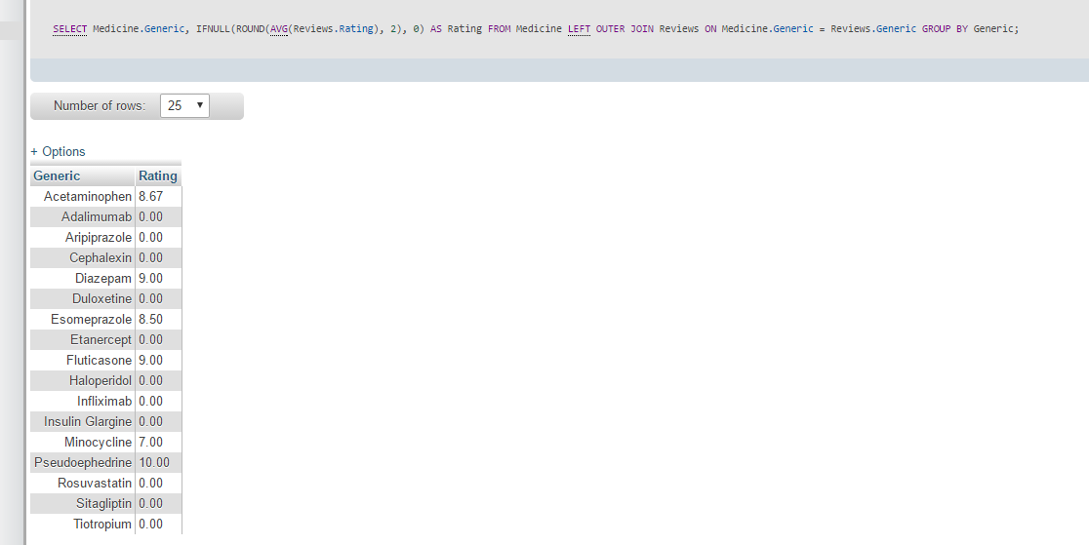

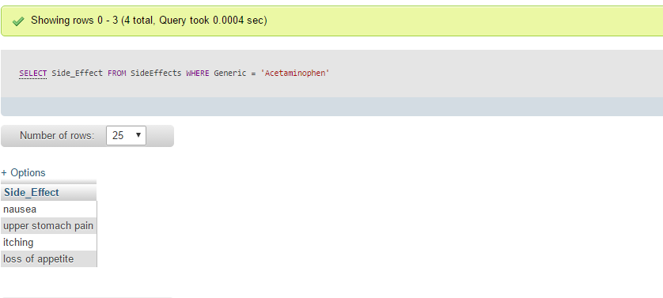

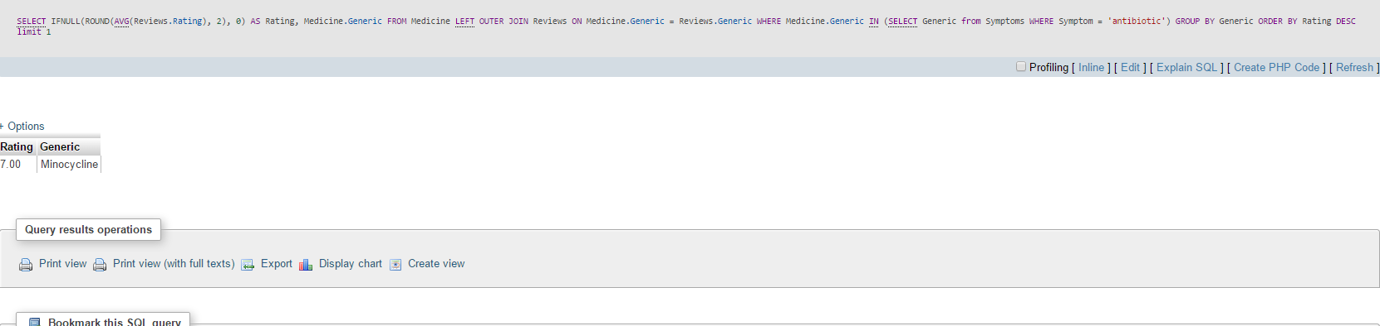



**Conclusion**

The database shows all the entities that correspond with the medicines. It displays the invoice that only correspond with certain symptoms. It lets the user update individual battery quantity and displays the symptoms as well as the ranking for a specific medication.